Soup Kitchen of Muncie
Presents

“Art & Chocolate”

An Evening to Meet the Artists
Westminster Village in Legacy Commons

Enjoy chocolate treats, music and
the art to be auctioned off March 16th
at the annual Soup Kitchen of Muncie dinner.
Meet the artists: Debbie Brown, Susie Burns, Kevin Campbell,
Missy Camille, Tony Costello, Emmanuel Guerra, Charlene George,
Ann Johnson, David Johnson, Sarojini Johnson, Jean McCauley,
Jan McCune, Alan Patrick, Ben Peak, John Peterson, Shelby Ping,
Margie Prim, Sarah Shaw, Carl Schafer, Jenny Smith,
Carol Strock-Wasson, Andrea Swartz, Julie Thorson and Dan Woodson

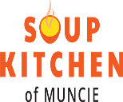
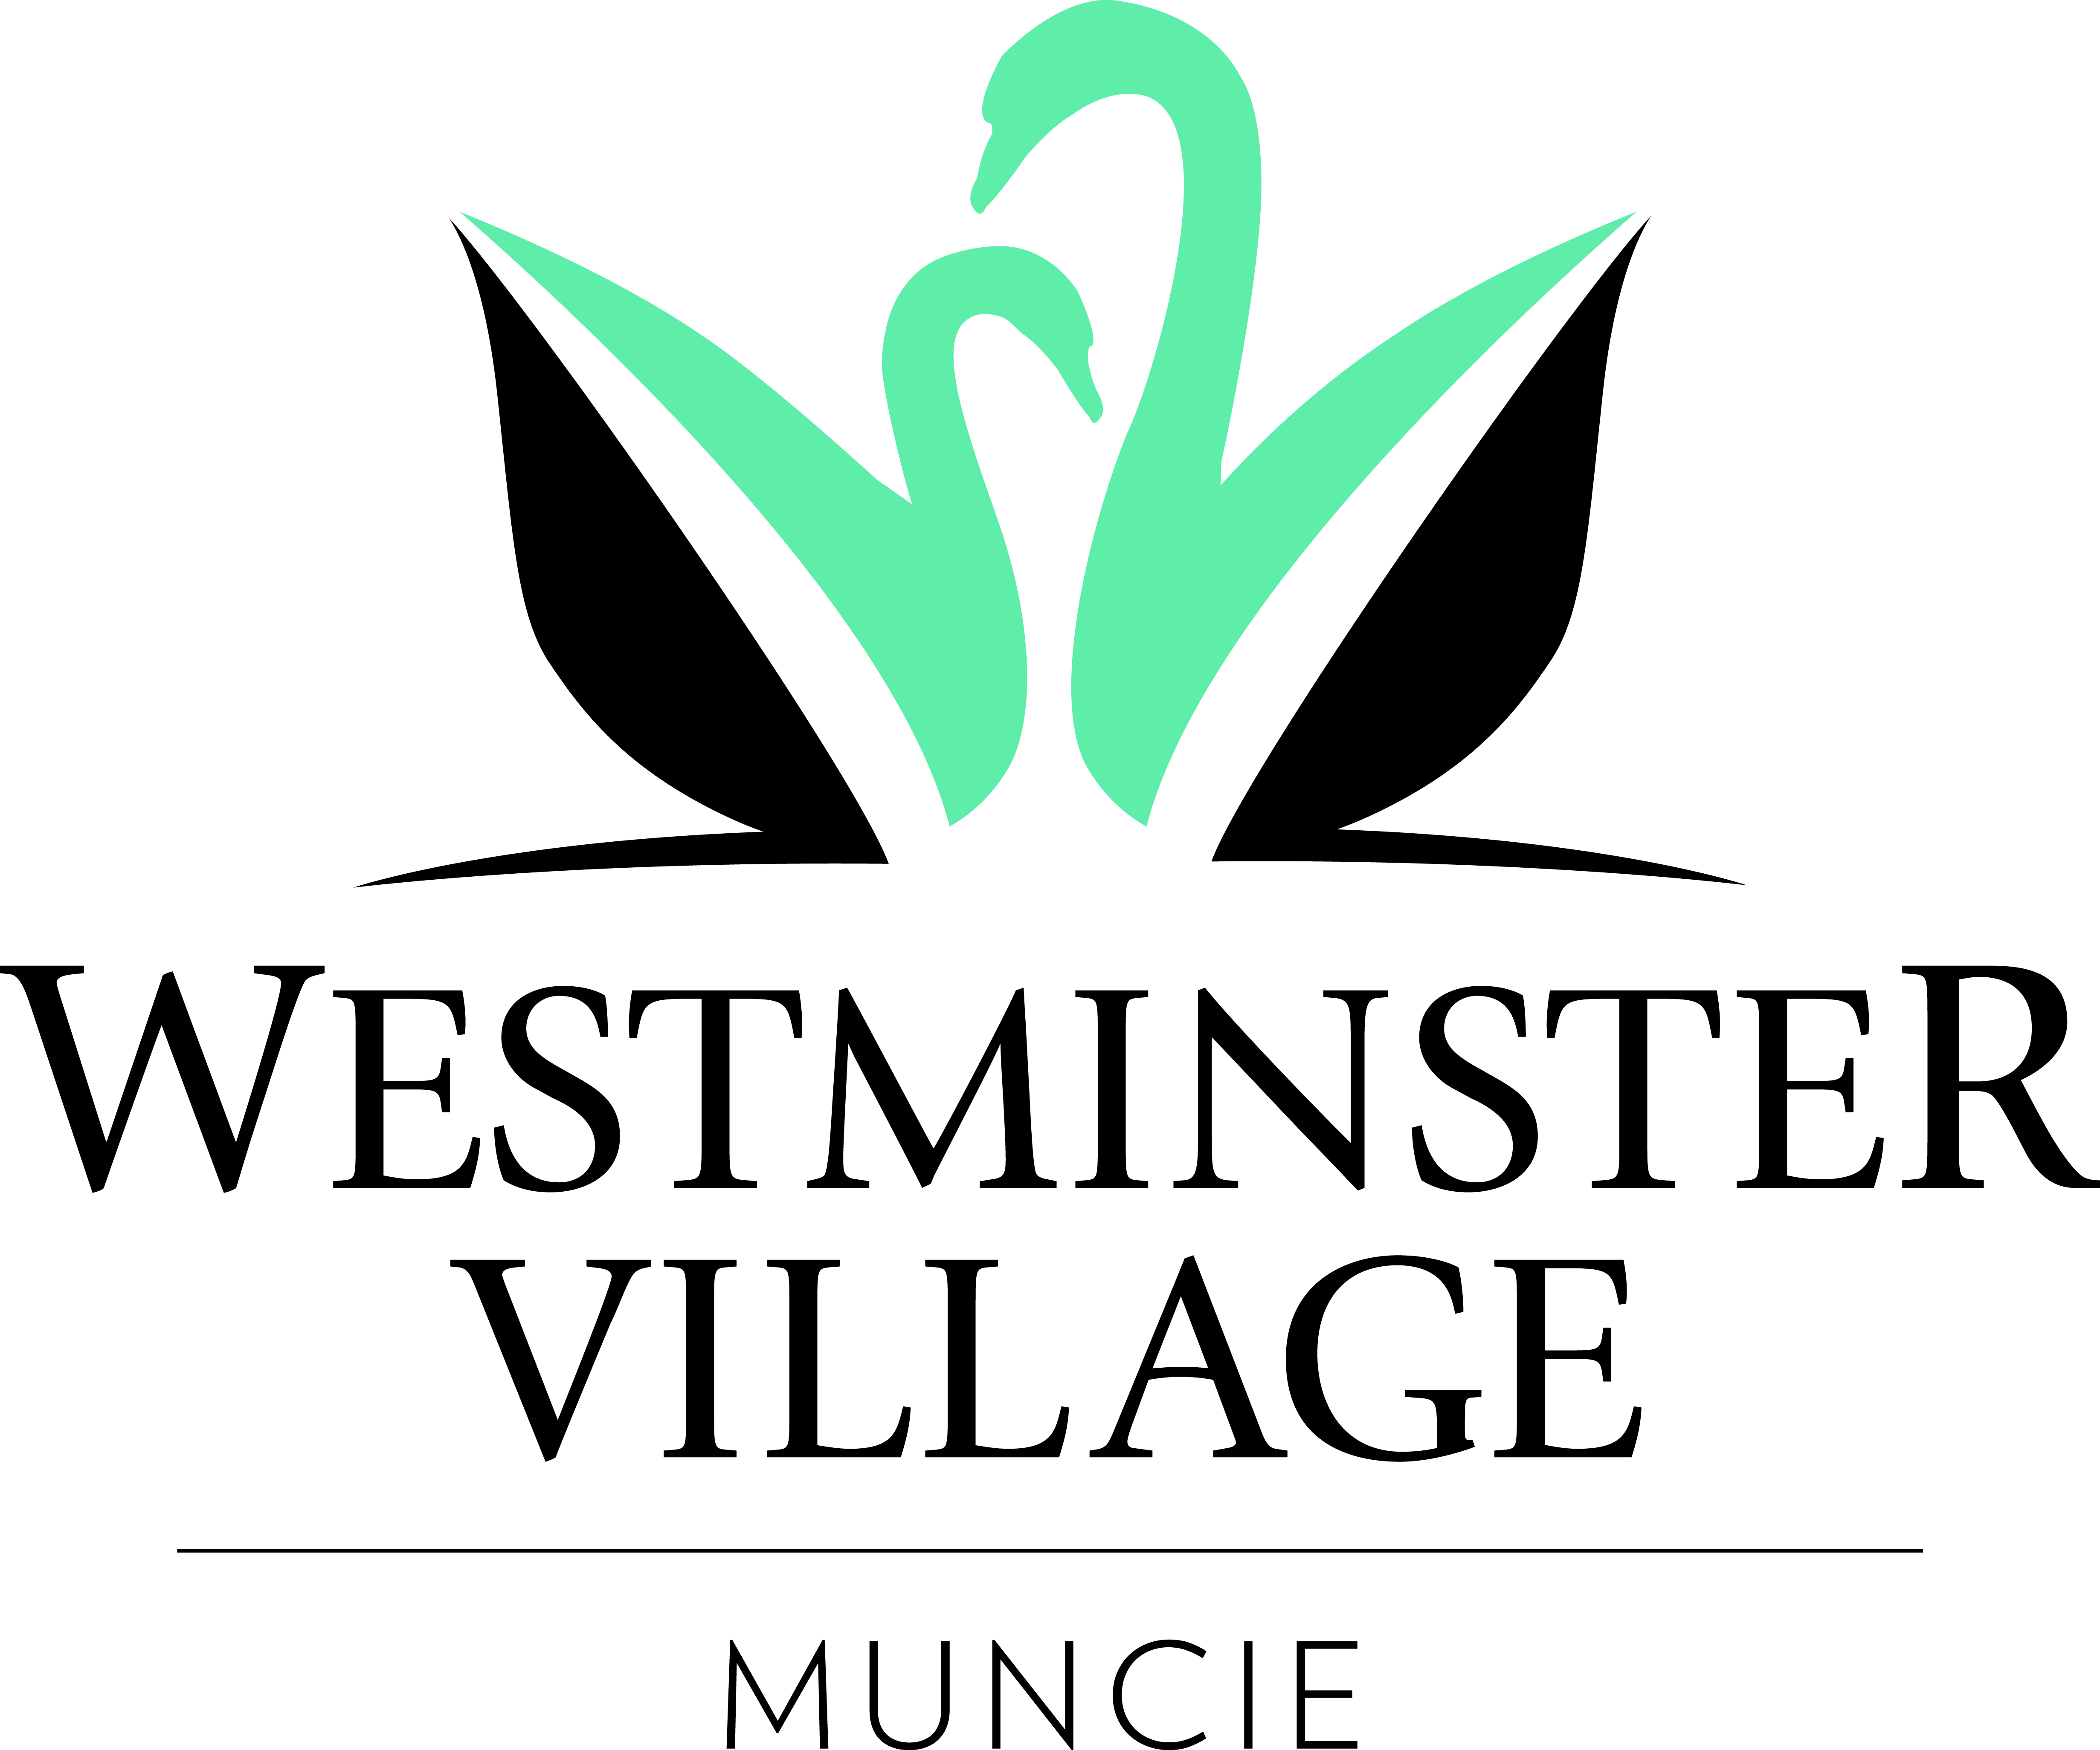

February 21, 2019
6:00 pm – 8:00 pm

5801 W. Bethel Avenue • 765-288-2155 • wvmuncie.com

