Soup Kitchen of Muncie
Presents

“Art & Chocolate”

An Evening to Meet
the Artists
at
Westminster Village
in Legacy Commons

Enjoy chocolate treats, music and
the art to be auctioned off March 16th
at the annual Soup Kitchen of Muncie dinner.

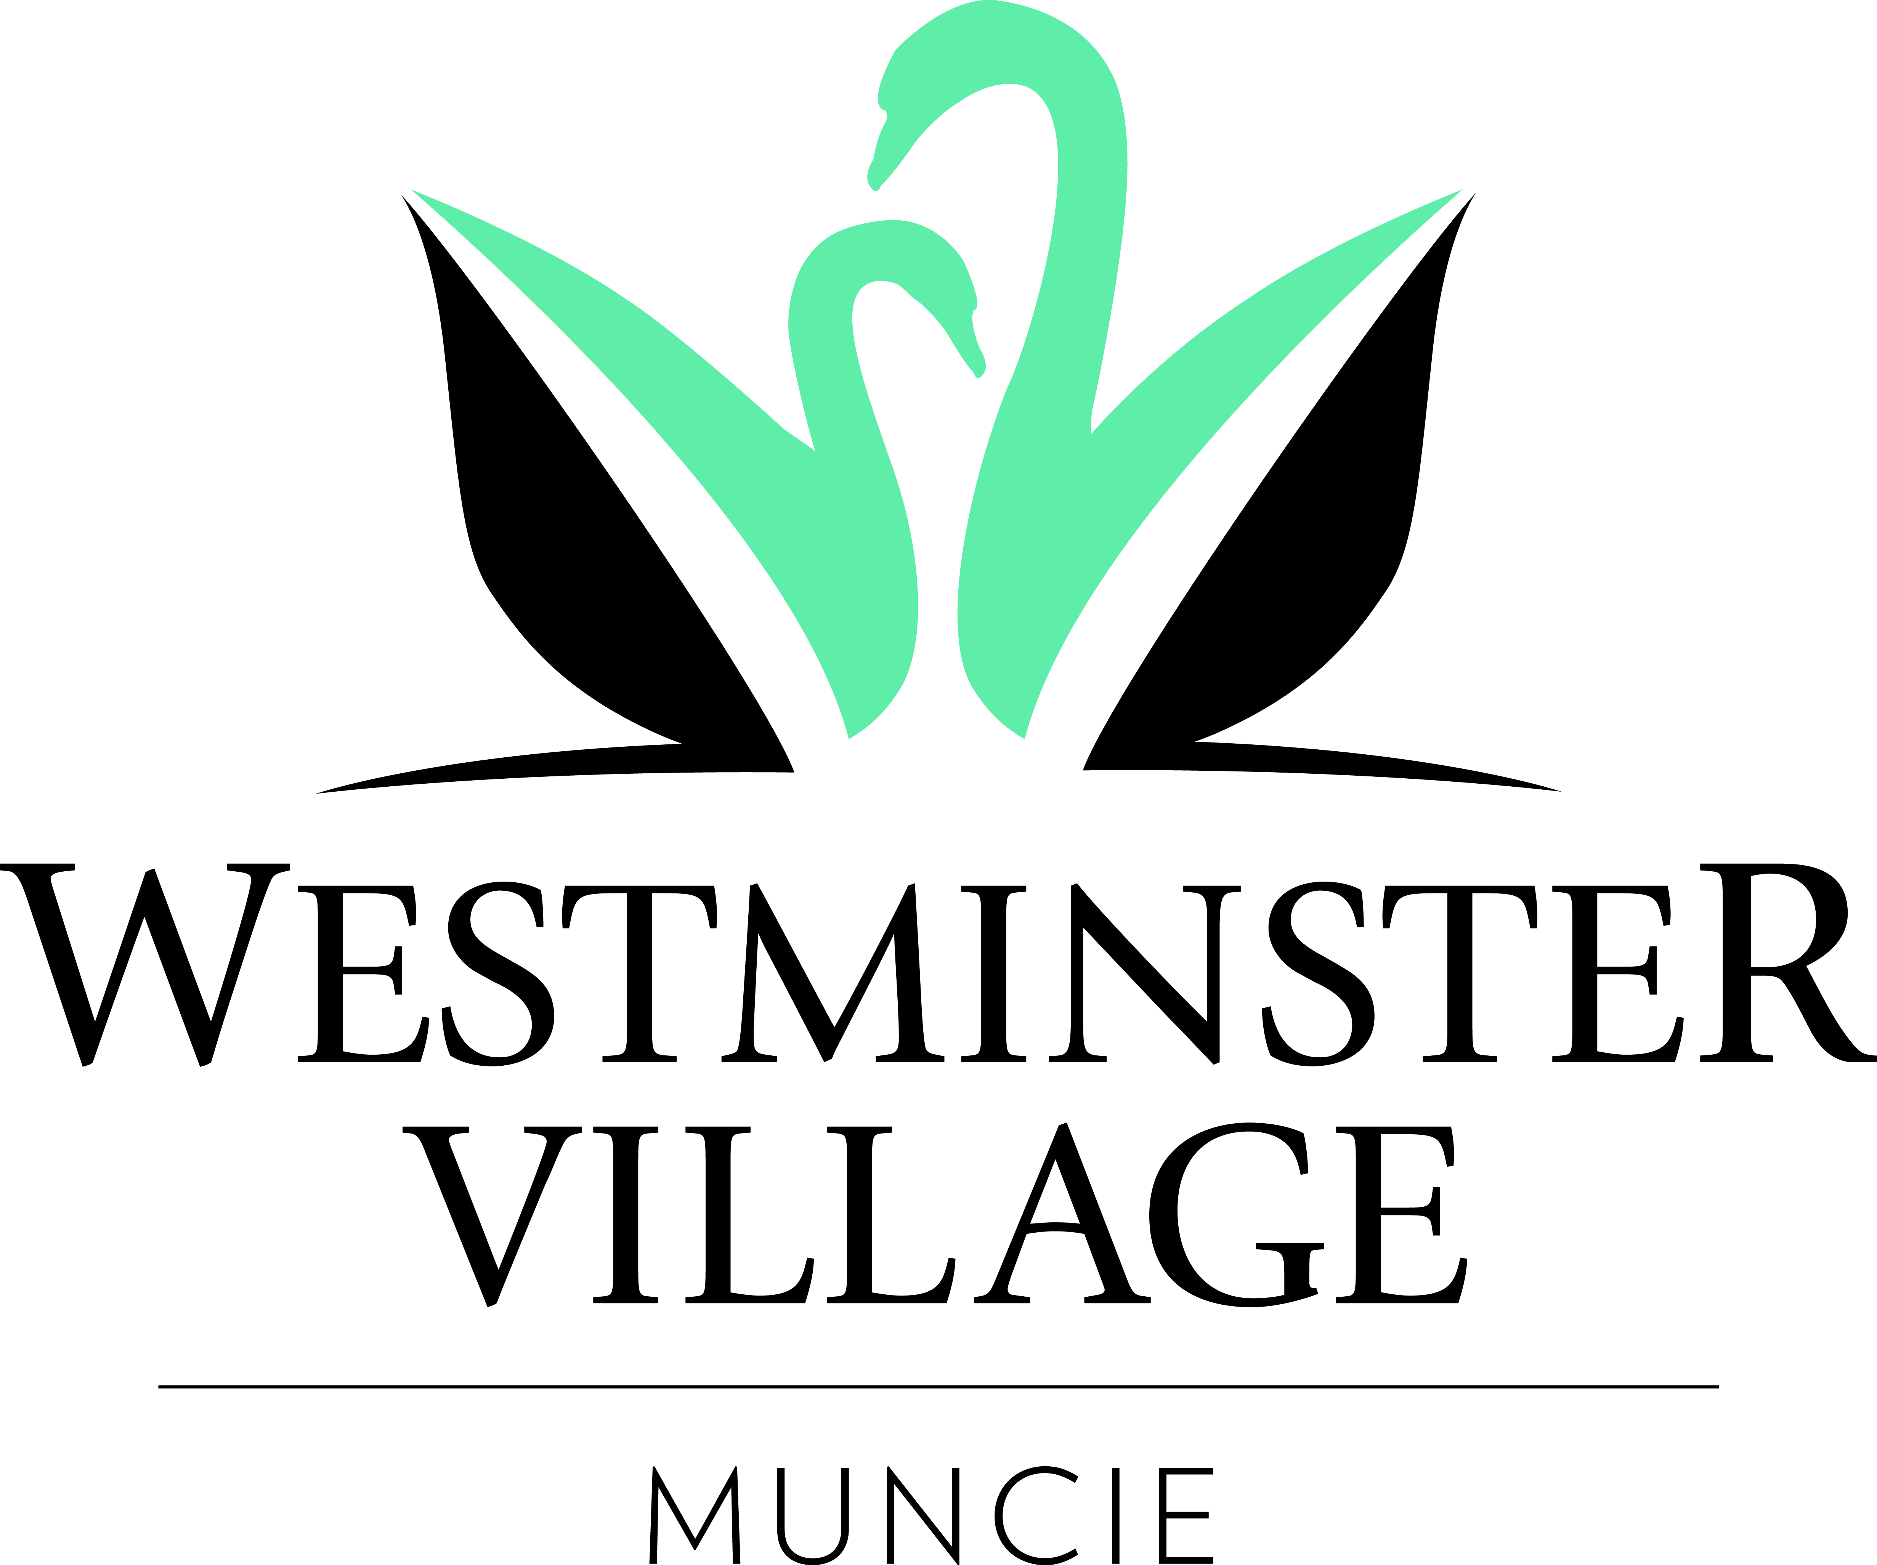
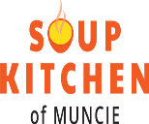
February 21, 2019

6:00 pm – 8:00 pm

5801 W. Bethel Avenue • 765-288-2155 • wvmuncie.com

